Name: Muhammad Shoaib Akhter Qadri

Enrollment No: 02-131212-009

Reg No: 79290

1. **Write a code of LED interface in Assembly and C through different P1, P2, P3 Block diagram of 8 LEDs**

**mov A,#055h 1. Perform Rotation operation 2. Perform four on and off 3. Two on and six off 4. Write a c code for above program.**

**Solution:**

ORG 00H ; Start of program

MOV A, #55H ;

MOV P1, A ;

; Perform Rotate Operation (Right Shift)

RR A ; Right rotate A through carry

MOV P1, A ; Output A to Port 1 (P1)

; Delay for visualization

MOV R2, #50

DELAY_LOOP:

DJNZ R2, DELAY_LOOP

; Four LEDs ON and OFF

MOV A, #0F0H ; Binary value for 11110000b (4 LEDs ON)

MOV P1, A ; Output A to Port 1 (P1)

; Delay for visualization

MOV R2, #50

DELAY_LOOP2:

DJNZ R2, DELAY_LOOP2

MOV A, #0F0H ; Binary value for 11110000b (4 LEDs OFF)

MOV P1, A ; Output A to Port 1 (P1)

; Delay for visualization

MOV R2, #50

DELAY_LOOP3:

DJNZ R2, DELAY_LOOP3

; Two LEDs ON and Six OFF

MOV A, #03CH ; Binary value for 00111100b (2 LEDs ON)

MOV P1, A ; Output A to Port 1 (P1)

; Delay for visualization

MOV R2, #50

DELAY_LOOP4:

DJNZ R2, DELAY_LOOP4

MOV A, #0C3H ; Binary value for 11000011b (6 LEDs OFF)

MOV P1, A ; Output A to Port 1 (P1)

; Delay for visualization

MOV R2, #50

DELAY_LOOP5:

DJNZ R2, DELAY_LOOP5

END ; End of program

1. **Blink alternate LEDs at P3 using software delay.**

ORG 00H ; Start of program

MAIN:

MOV A, #55H ; Initial value for alternate LEDs (01010101b)

MOV P3, A ; Output to P3

ACALL DELAY ; Call delay subroutine

CPL A ; Complement A (Toggle LEDs)

MOV P3, A ; Output to P3

ACALL DELAY ; Call delay subroutine

SJMP MAIN ; Repeat

DELAY:

; Implement a delay loop here

; Adjust the loop count to control the delay

MOV R1, #0FFH

DELAY_LOOP:

DJNZ R1, DELAY_LOOP

RET

END ; End of program

1. **Blink P0 LEDs in cyclic fashion using software delay.**

ORG 00H ; Start of program

MAIN:

MOV A, #01H ; Initial value for cyclic LEDs (00000001b)

MOV P0, A ; Output to P0

ACALL DELAY ; Call delay subroutine

RLC A ; Rotate left through carry (cyclic shift)

MOV P0, A ; Output to P0

ACALL DELAY ; Call delay subroutine

SJMP MAIN ; Repeat

DELAY:

; Implement a delay loop here

; Adjust the loop count to control the delay

MOV R1, #0FFH

DELAY_LOOP:

DJNZ R1, DELAY_LOOP

RET

END ; End of program

1. **Count the number of times a switch at P1.1 is pressed and display the count in P2If you have any doubt please comment below.**

ORG 00H ; Start of program

COUNT EQU 30H ; Memory location for the count

MAIN:

MOV P1, #02H ; Configure P1.1 as an input

MOV A, P1 ; Read P1 into A

MOV R2, A ; Store the current state of P1.1

CLR A ; Clear A

MOV COUNT, A ; Clear the count

CHECK_SWITCH:

MOV A, P1 ; Read P1 into A

XRL A, R2 ; Check for changes in P1.1

JZ NO_CHANGE

INC COUNT ; Increment count when P1.1 is pressed

NO_CHANGE:

MOV R2, A ; Update the state of P1.1

MOV P2, A ; Display the count on P2

SJMP CHECK_SWITCH ; Repeat

END ; End of program

1. **Draw the Block diagram of seven segment display and write its code in C and Assembly**

**Solution:**

**C Code:**

#include <reg52.h>

#define SEGMENT_PORT P2 // Assuming P2 is connected to the seven-segment display

const unsigned char SevenSegDigits[] = {

0xC0,

0xF9,

0xA4,

0xB0,

0x99,

0x92,

0x82,

0xF8,

0x80,

0x90

};

void main() {

unsigned char digit = 0;

while (1) {

SEGMENT_PORT = SevenSegDigits[digit];

delay();

digit = (digit + 1) % 10;

}

}

void delay() {

unsigned int i, j;

for (i = 0; i < 1000; i++) {

for (j = 0; j < 100; j++) {

}

}

}

**Assembly Code (for 8051 microcontroller):**

ORG 00H

MAIN:

MOV R0, #00H

LOOP:

MOV A, R0

ADD A, #48

MOV P2, A

ACALL DELAY

INC R0

CJNE R0, #10, LOOP

SJMP MAIN

DELAY:

MOV R1, #0FFH

DELAY_LOOP:

DJNZ R1, DELAY_LOOP

RET

END

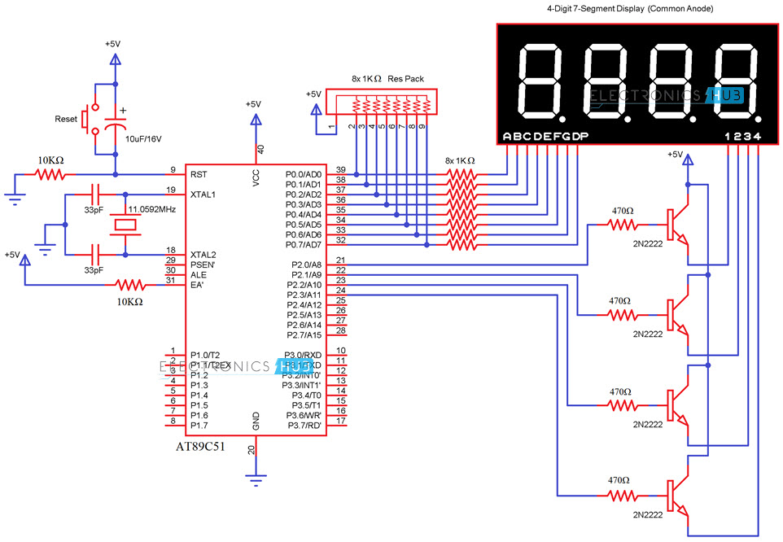

1. **Draw block diagram of two seven segment display**

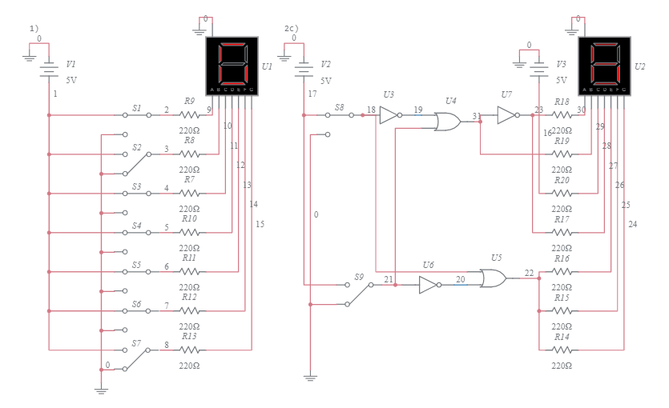

1. **Write a program in Assembly and C to display a digit from 0 to 9 in both seven segment display.**

**C Code:**

#include <reg52.h>

sbit Display1 = P2^0; // Common pin for the first display

sbit Display2 = P2^1; // Common pin for the second display

const unsigned char SevenSegDigits[] = {

0xC0,

0xF9,

0xA4,

0xB0,

0x99,

0x92,

0x82,

0xF8,

0x80,

0x90

};

void main() {

unsigned char digit = 0;

while (1) {

Display1 = 0;

Display2 = 1;

P0 = SevenSegDigits[digit];

delay();

Display1 = 1;

Display2 = 0;

P0 = SevenSegDigits[digit];

delay(); // Implement a delay function

digit = (digit + 1) % 10;

}

}

void delay() {

unsigned int i, j;

for (i = 0; i < 1000; i++) {

for (j = 0; j < 100; j++) {

// Delay loop

}

}

}

**Assembly Code:**

ORG 00H ;

MAIN:

MOV R0, #00H ;

MOV P2, #03H ;

LOOP:

MOV A, R0 ;

ADD A, #48 ;

CJNE P2, #01H, DIS1 ;

MOV P0, A ;

SJMP NEXT

DIS1:

MOV P0, A ;

NEXT:

ACALL DELAY ;

INC R0 ;

CJNE R0, #10, LOOP ;

SJMP MAIN

DELAY:

; Implement a delay subroutine

; Adjust the loop count to control the delay

MOV R1, #0FFH

DELAY_LOOP:

DJNZ R1, DELAY_LOOP

RET

END ; End of program

**Assignment # 02**

**Write a program to display a well come to bahria in LCD display.**

#include <LiquidCrystal.h>

LiquidCrystal lcd(13,12,11,6,5,4,3);

void setup() {

// set up the LCD's number of columns and rows:

lcd.begin(16, 2);

// Print a message to the LCD.

lcd.print("Shoaib Akhter");

}

void loop() {

lcd.setCursor(0, 1);

lcd.print(millis() / 1000);

